Cpu54前仿真波形图及比对结果

1.Addi

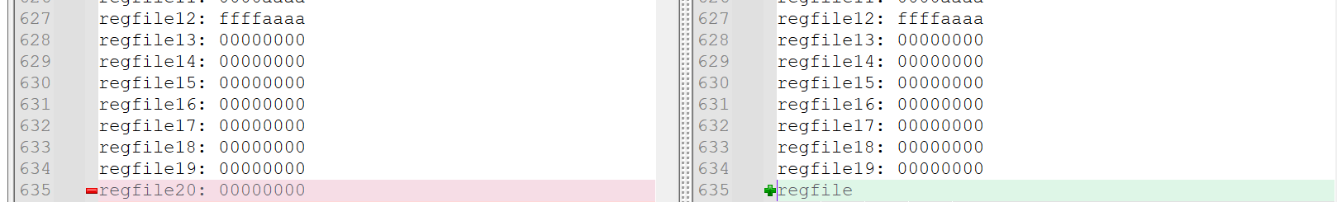

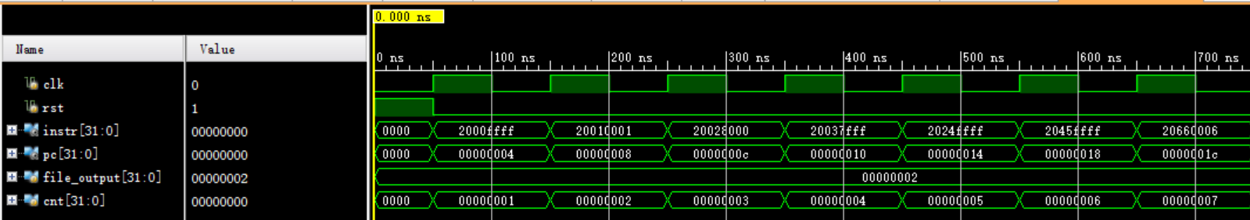

2.Addiu

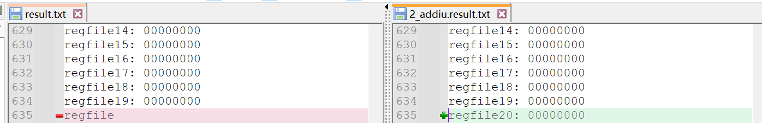

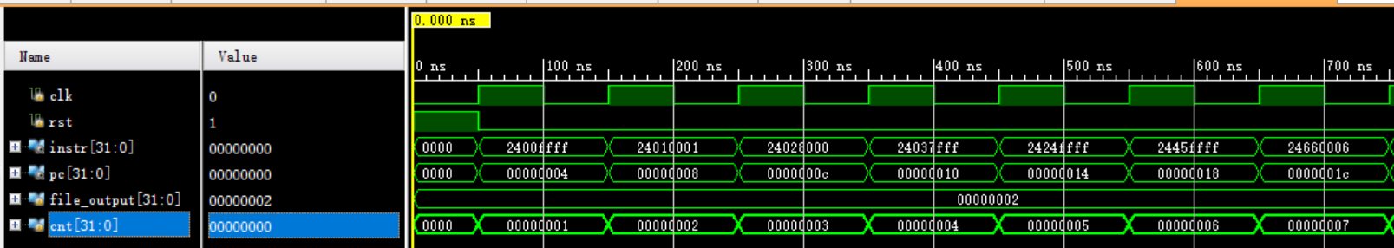

3.Andi

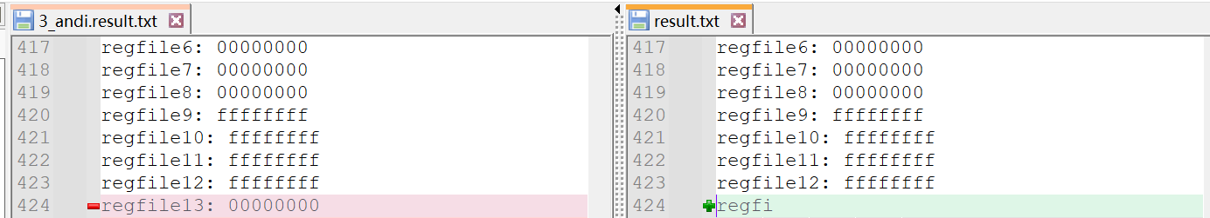

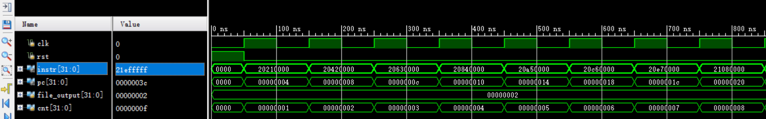

4.Ori

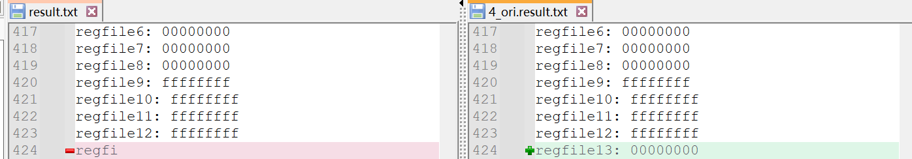

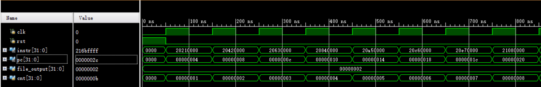

5.Sltiu

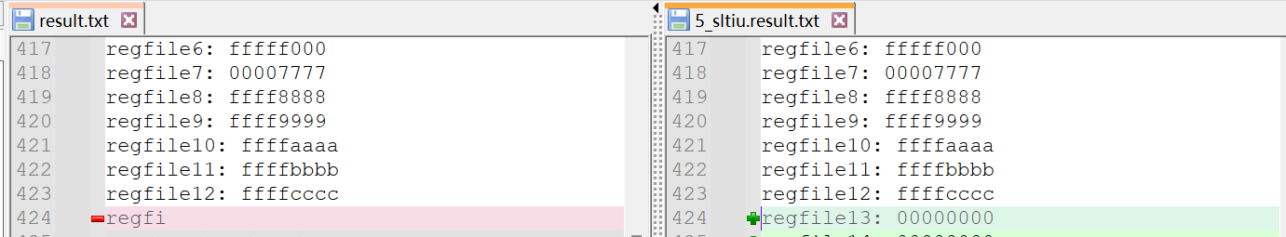

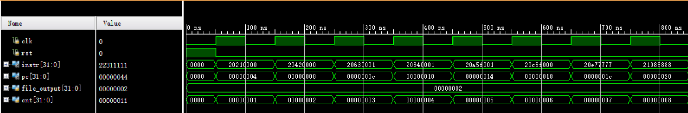

6.Lui

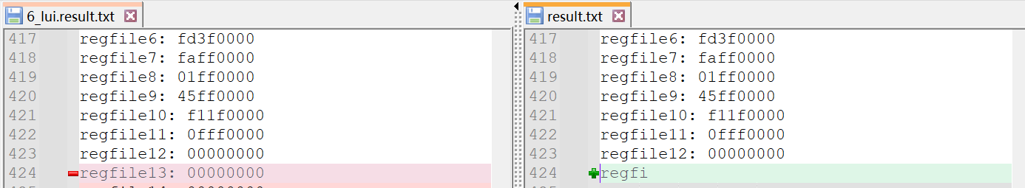

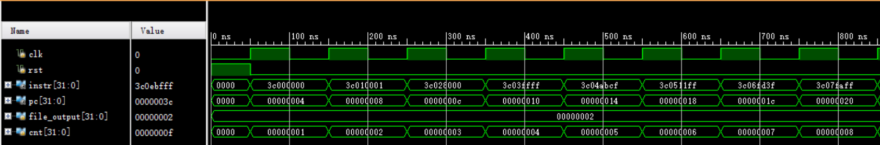

7.Xori

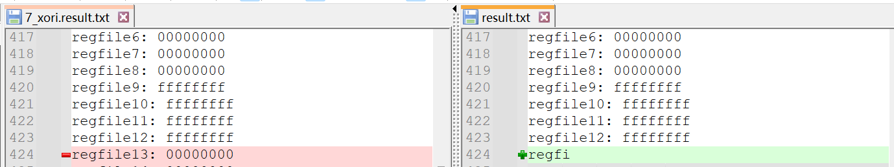

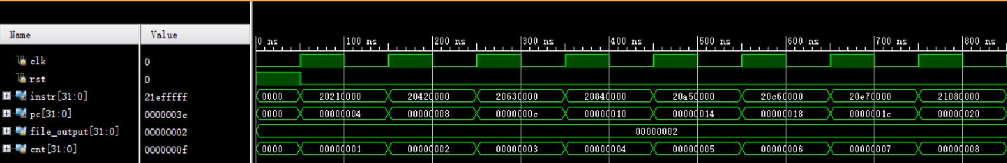

8.Slti

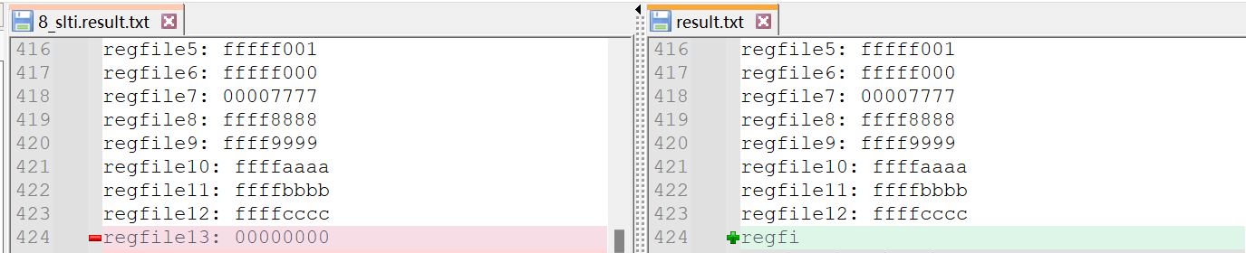

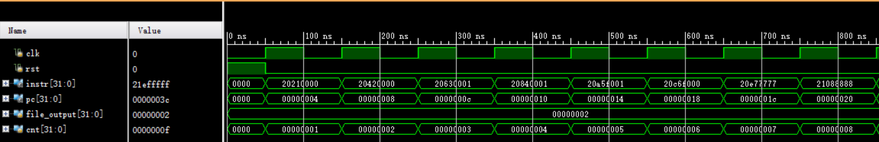

9.Addu

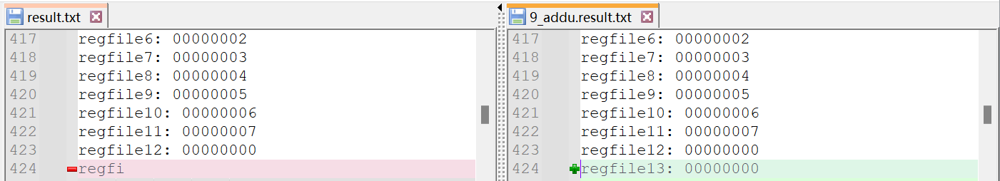

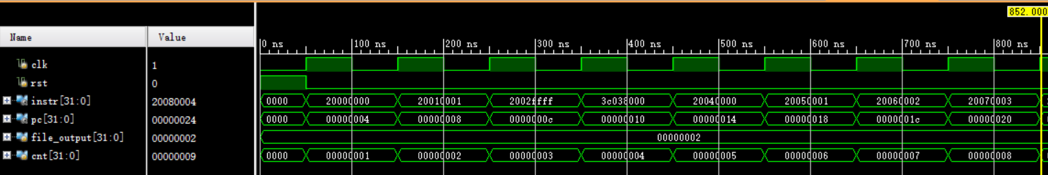

10.And

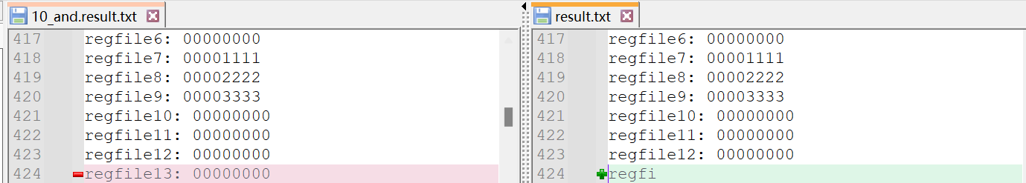

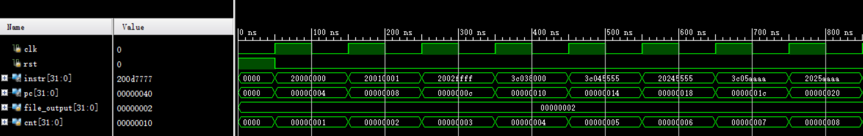

11.Beq

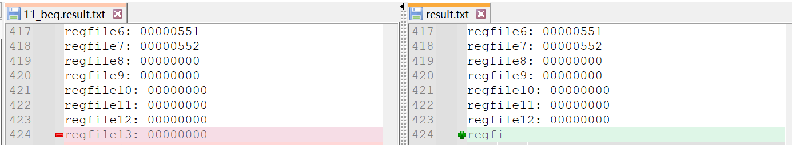

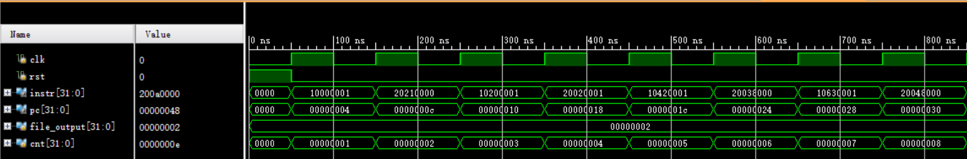

12.Bne

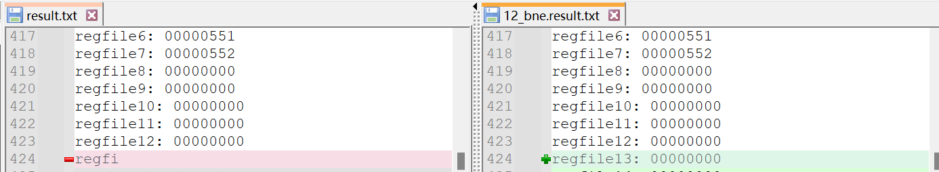

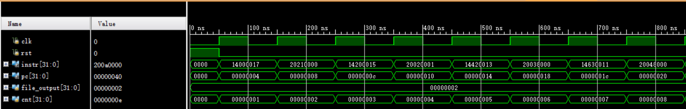

13.J

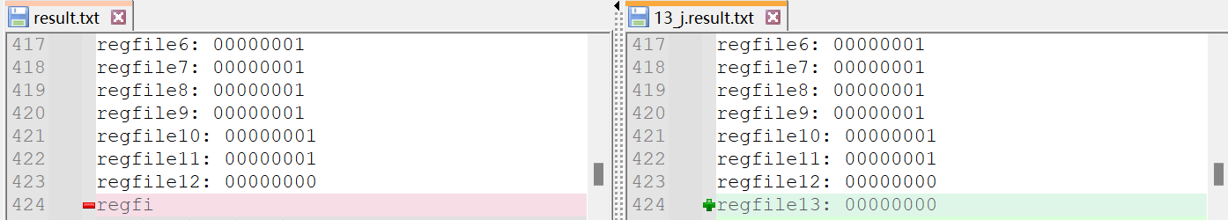

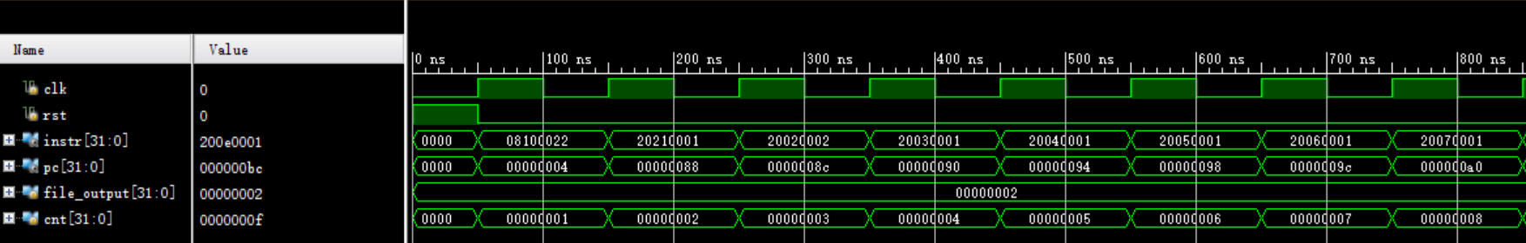

14.Jal

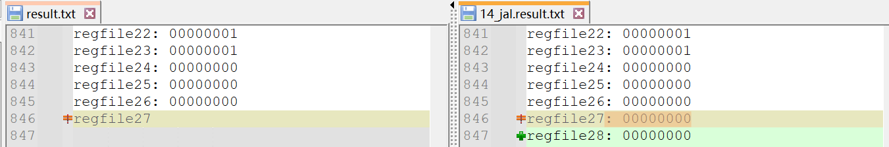

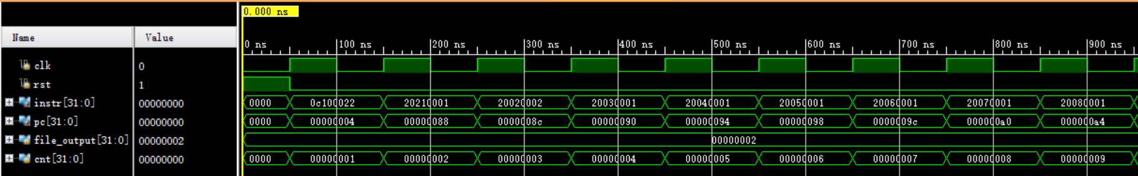

15.Jr

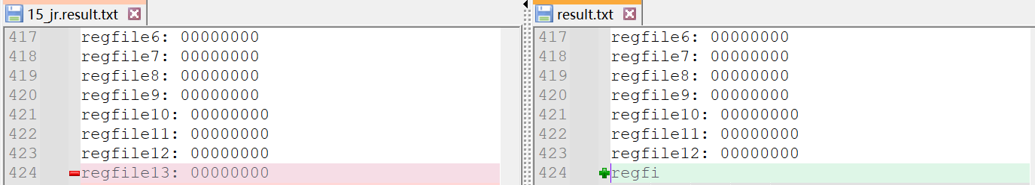

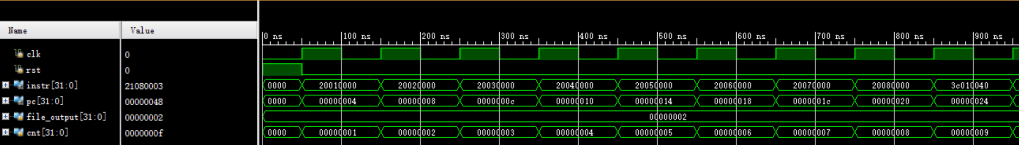

16.

LwSw

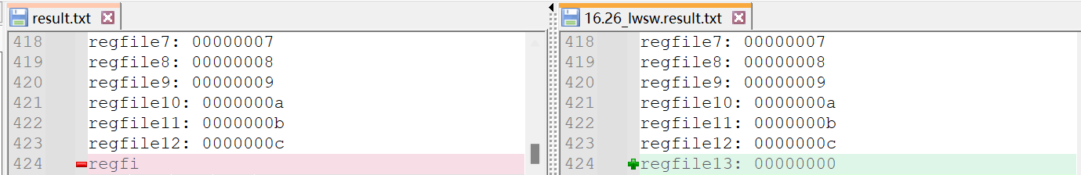

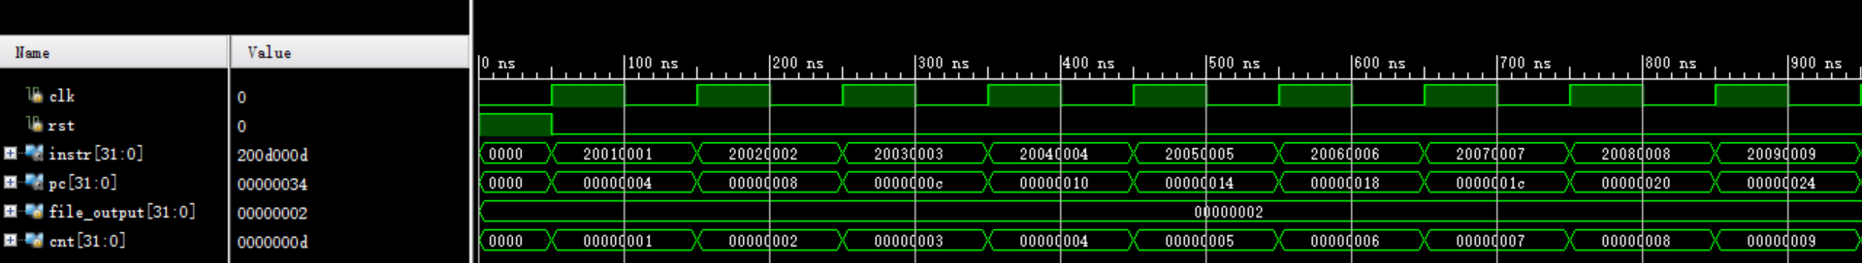

LwSw2

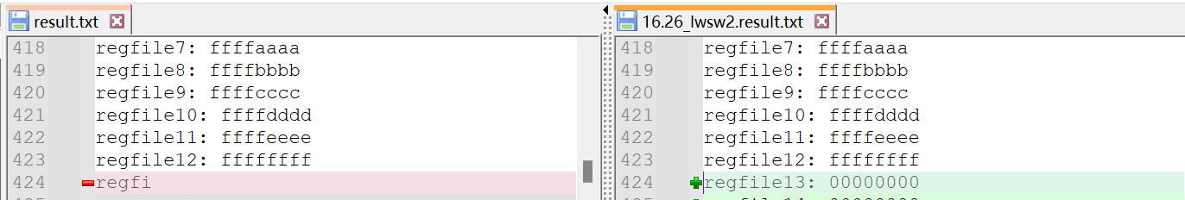

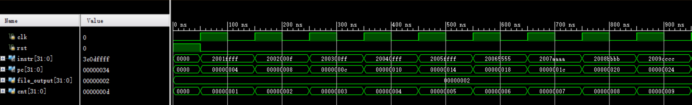

17.Xor

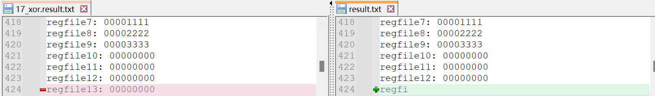

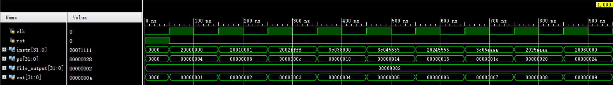

18.Nor

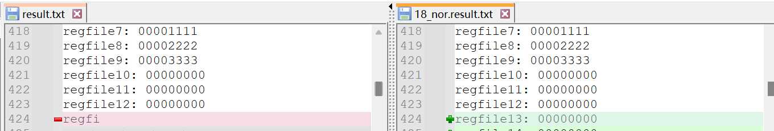

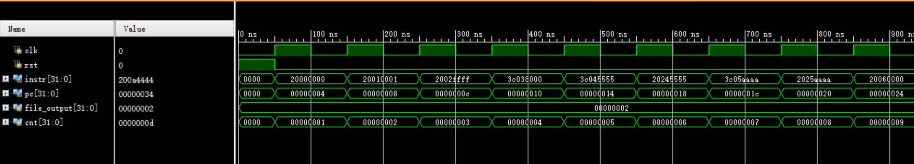

19.Or

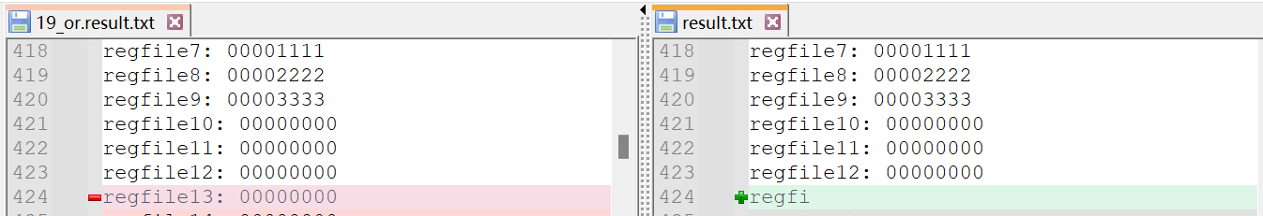

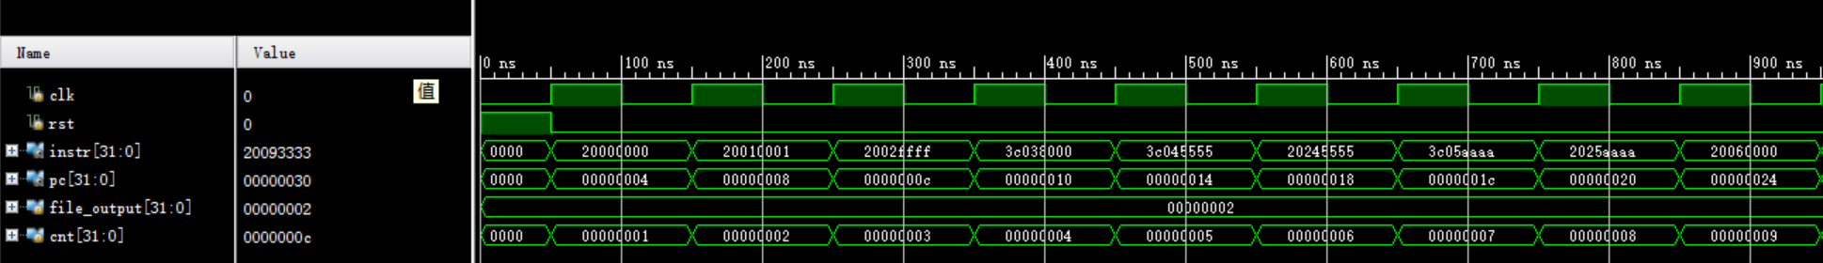

20.Sll

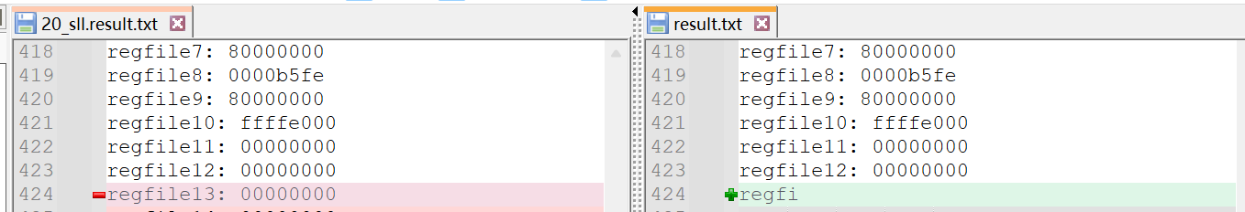

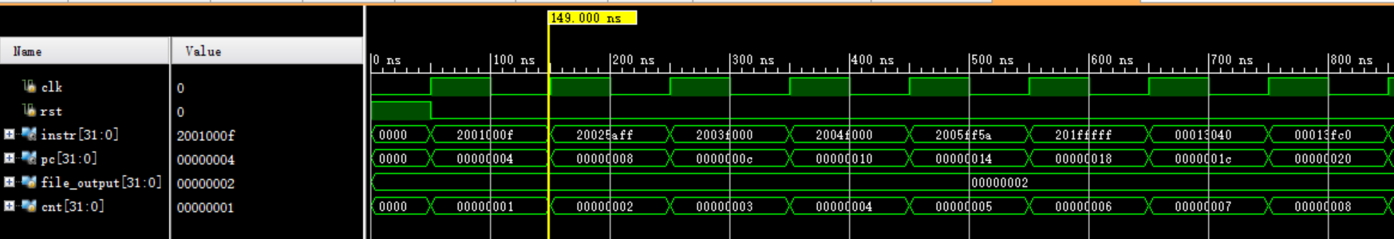

21.Sllv

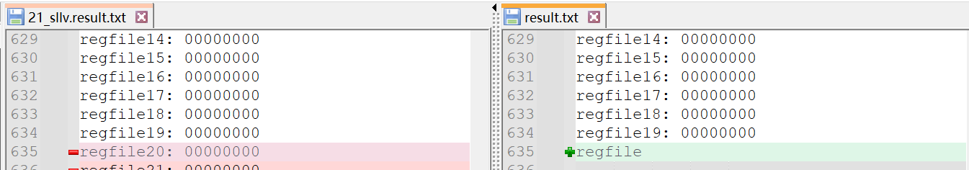

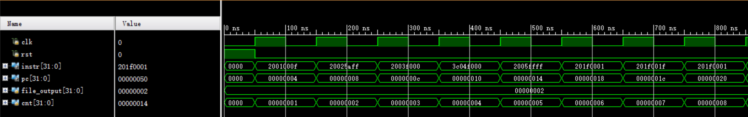

22.Sltu

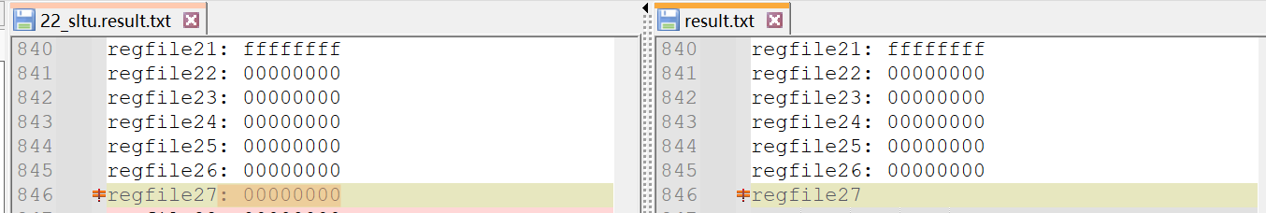

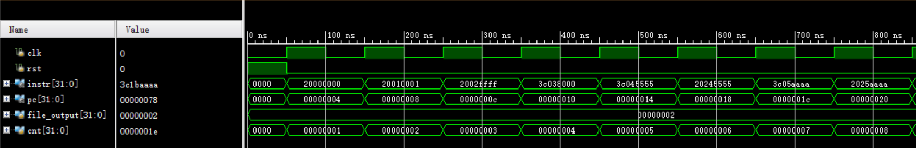

23.Sra

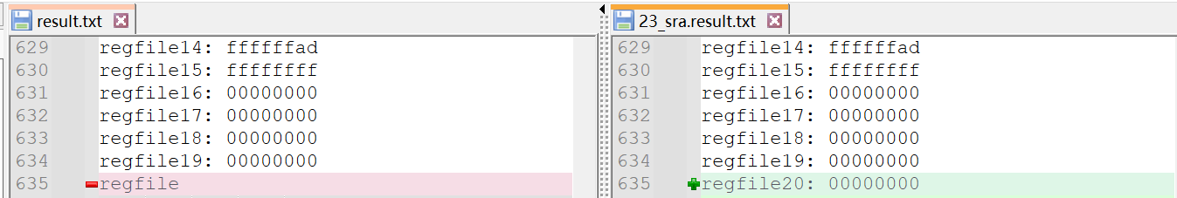

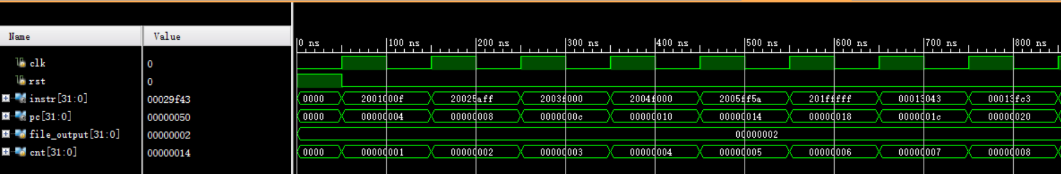

24.Srl

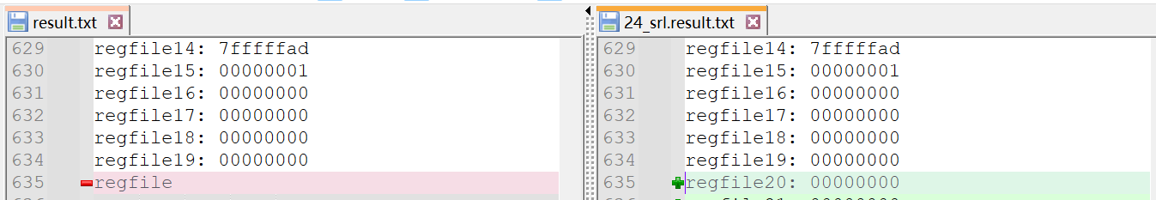

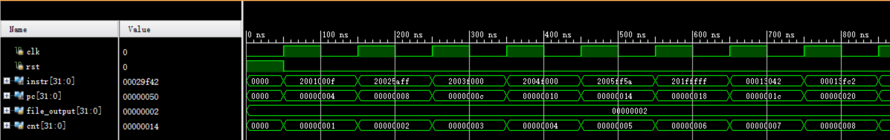

25.Subu

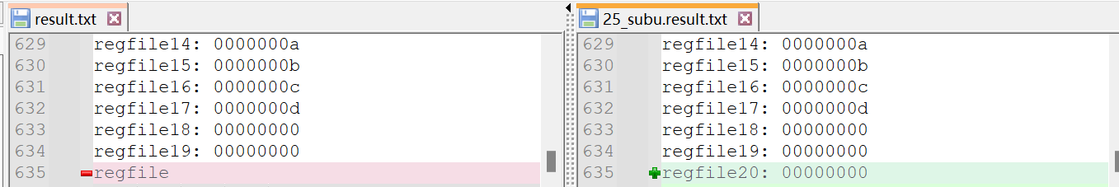

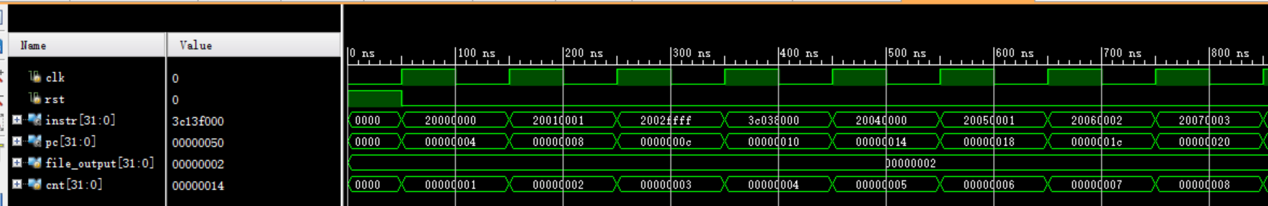

26.16已经测试

27.Add

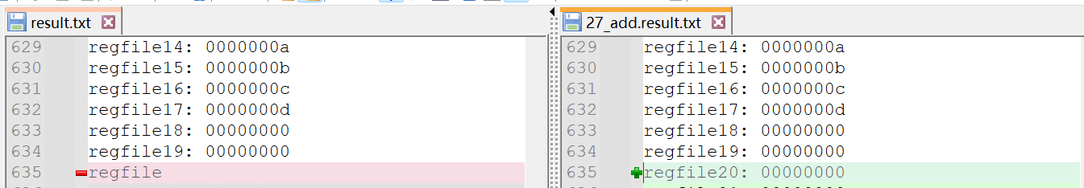

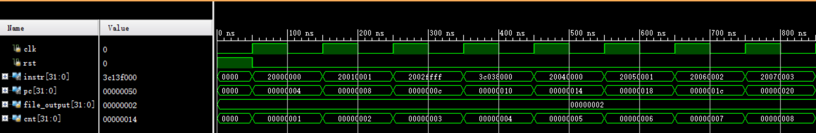

28.Sub

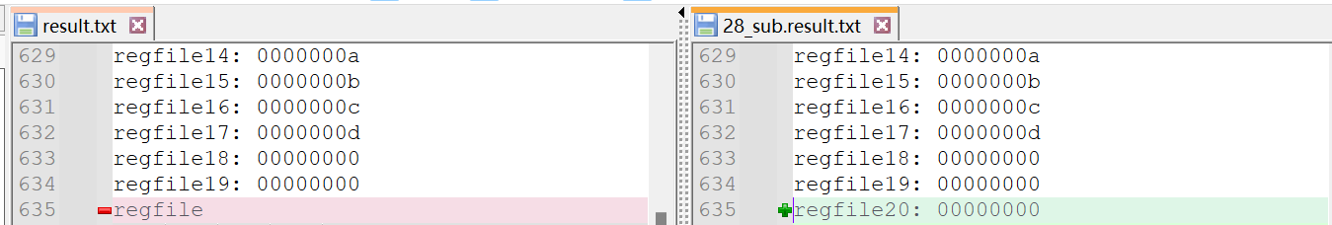

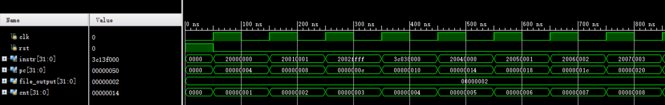

29.Slt

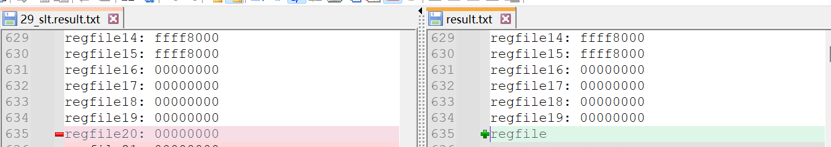

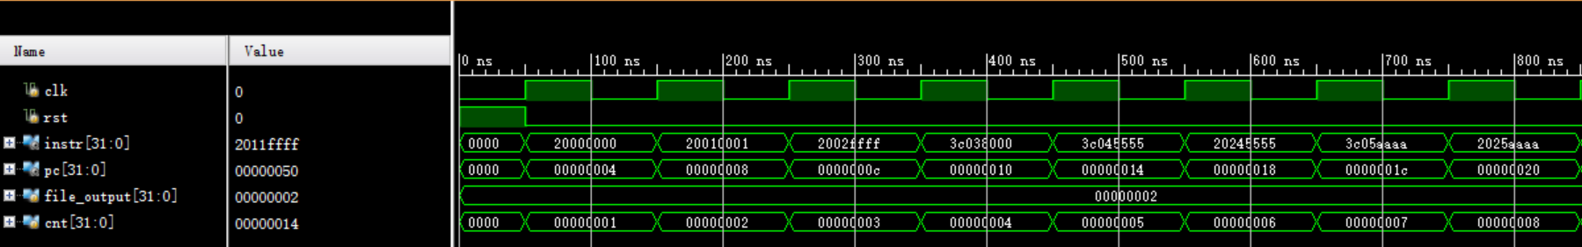

30.Srlv

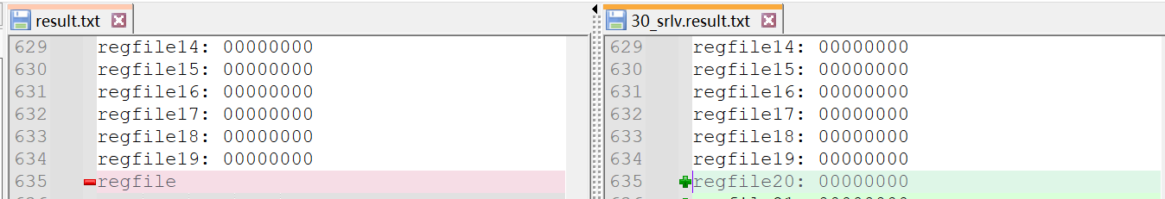

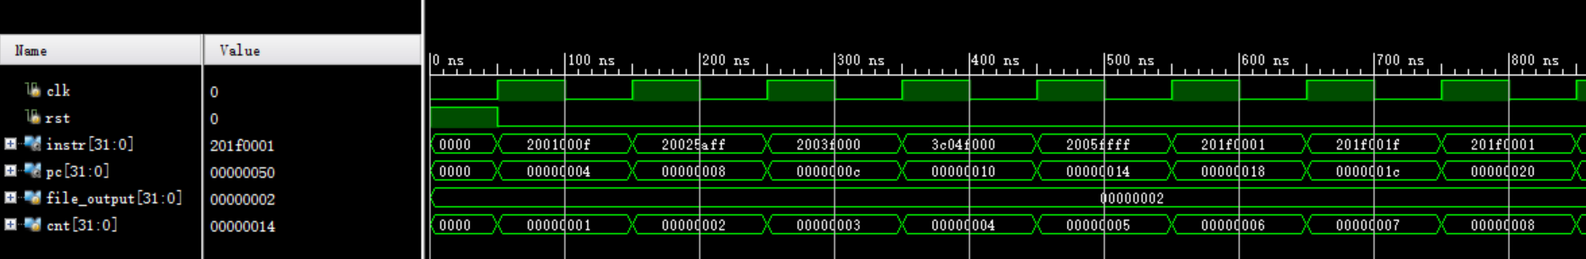

31.Srav

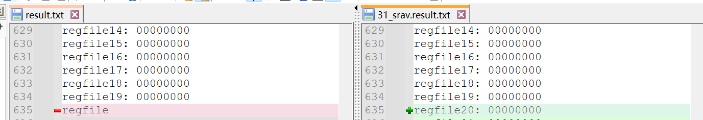

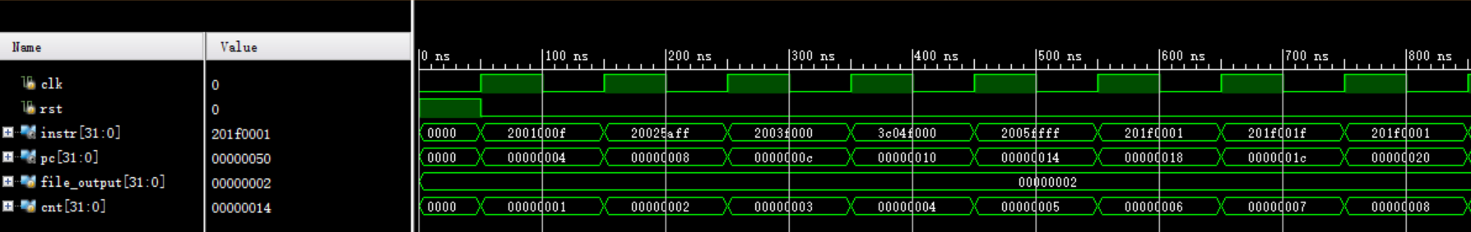

32.Clz

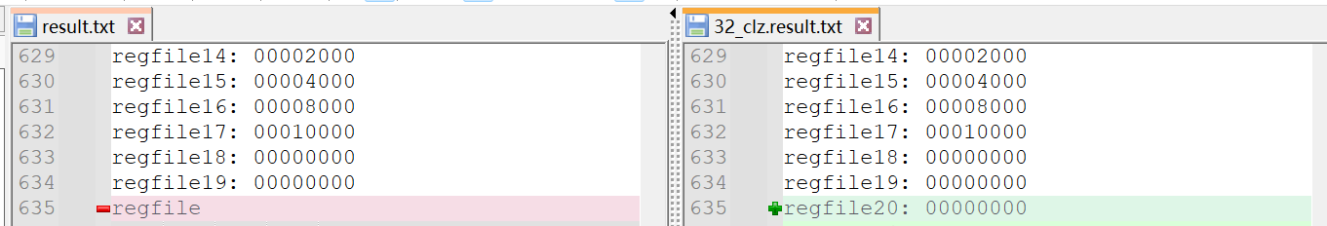

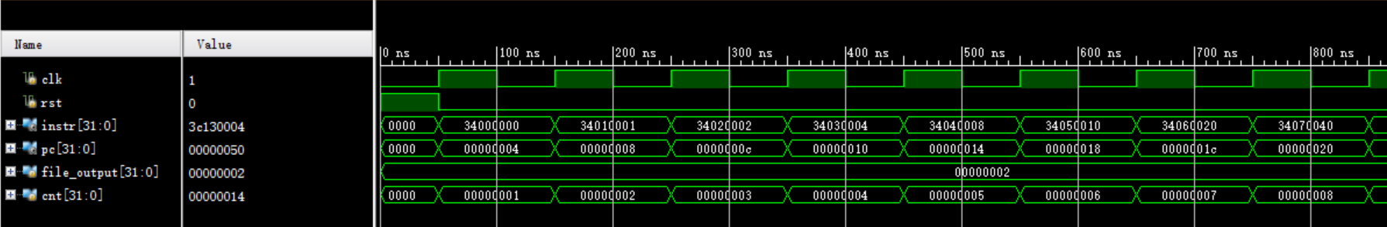

33.Divu

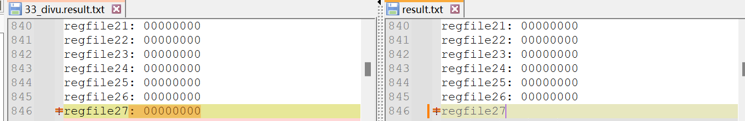

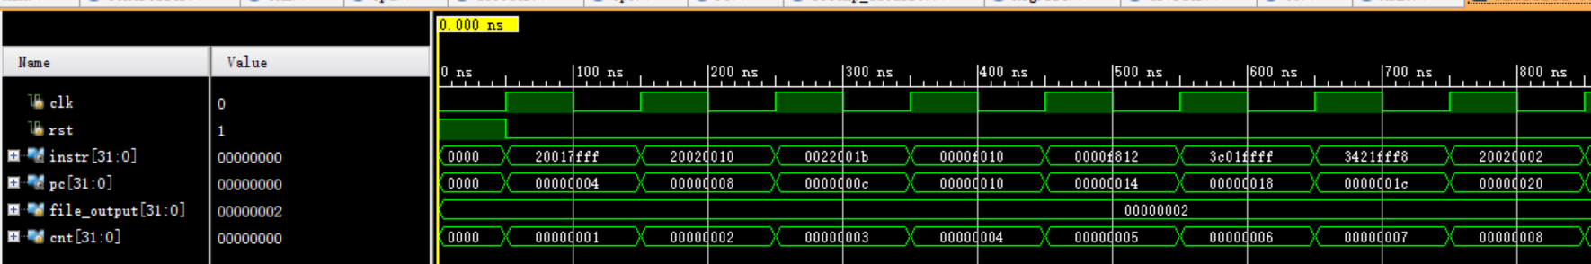

35. Jalr

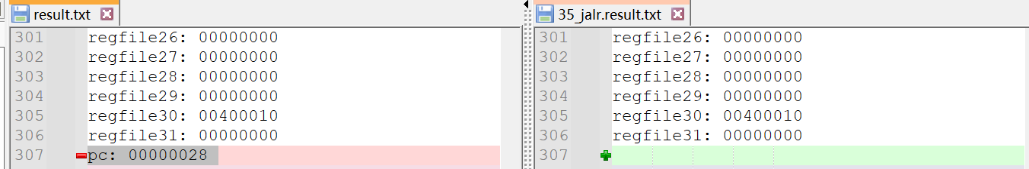

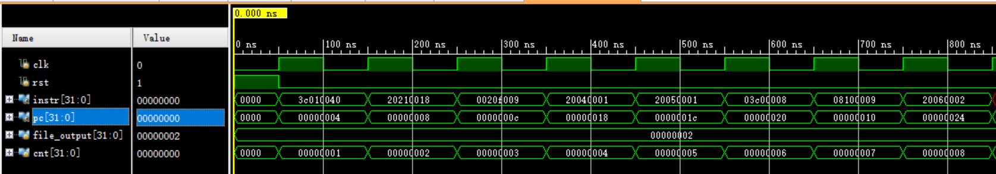

36.39 LbSb

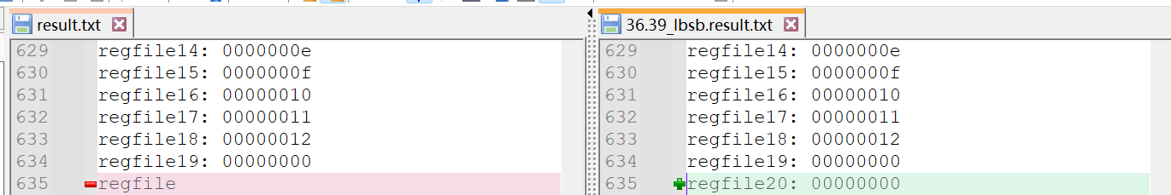

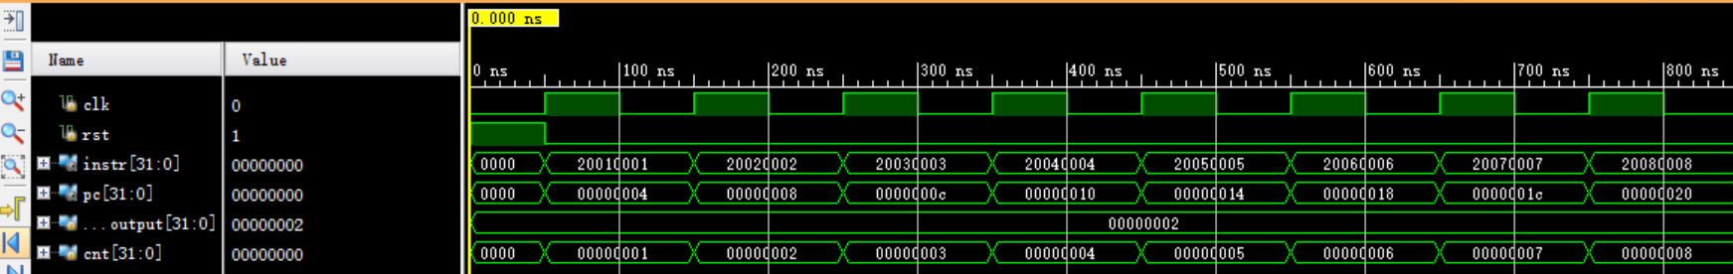

LbSb2

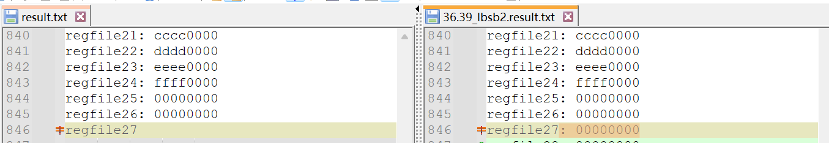

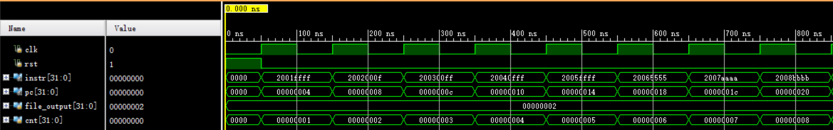

37.Lbu

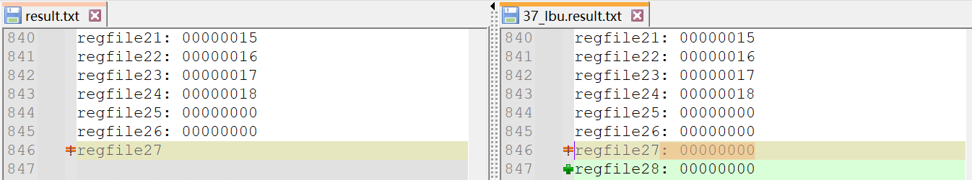

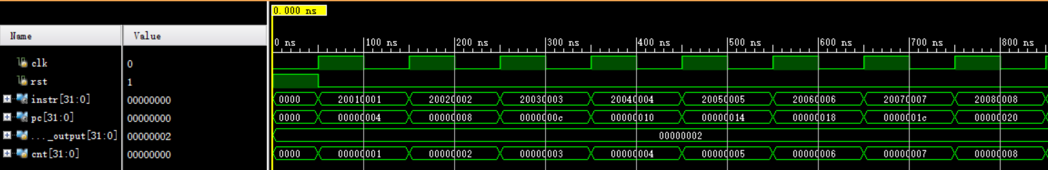

Lbu2

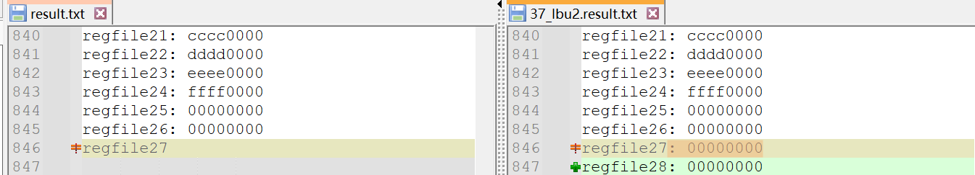

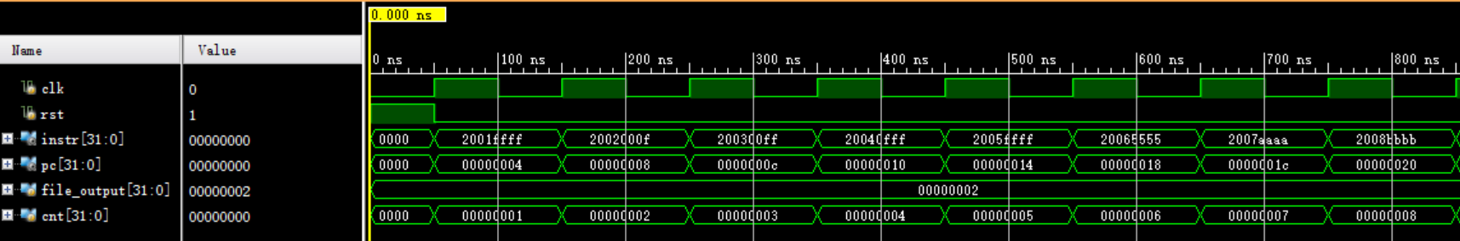

38.Lhu

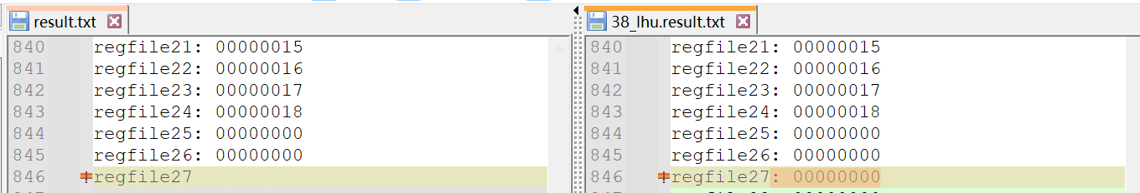

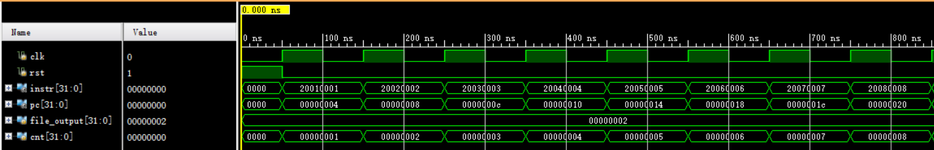

39.Lhu2

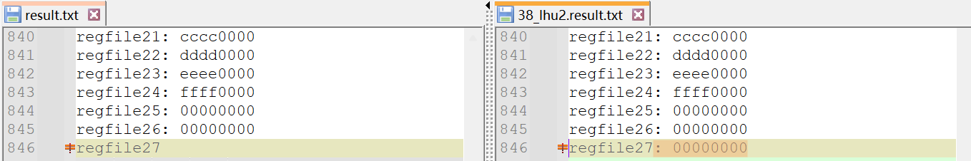

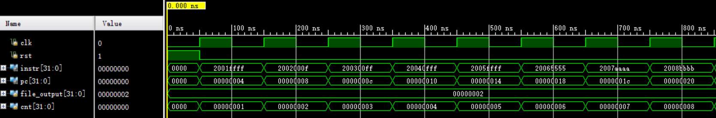

40.Lhsh

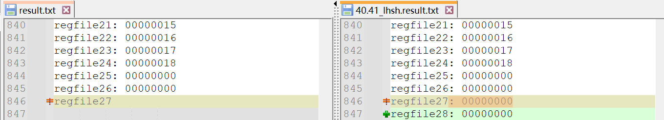

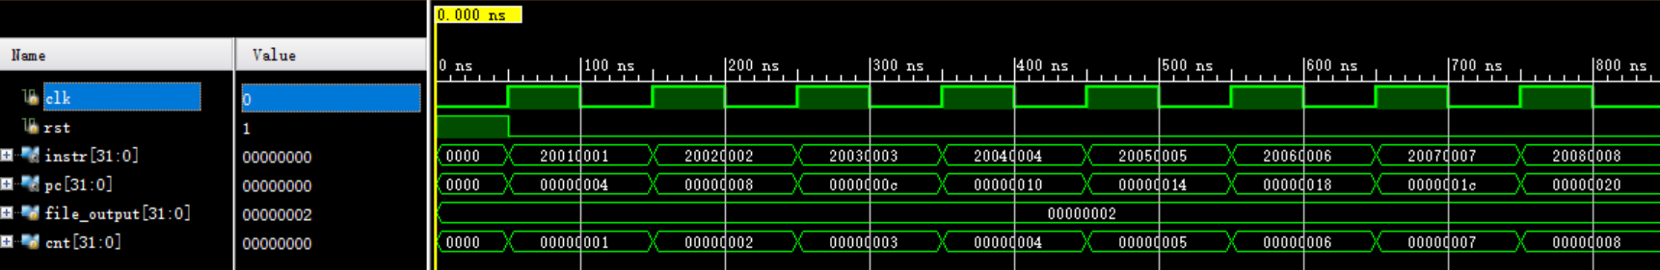

41.Lhsh2

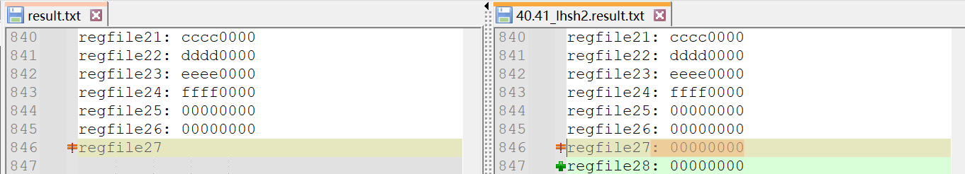

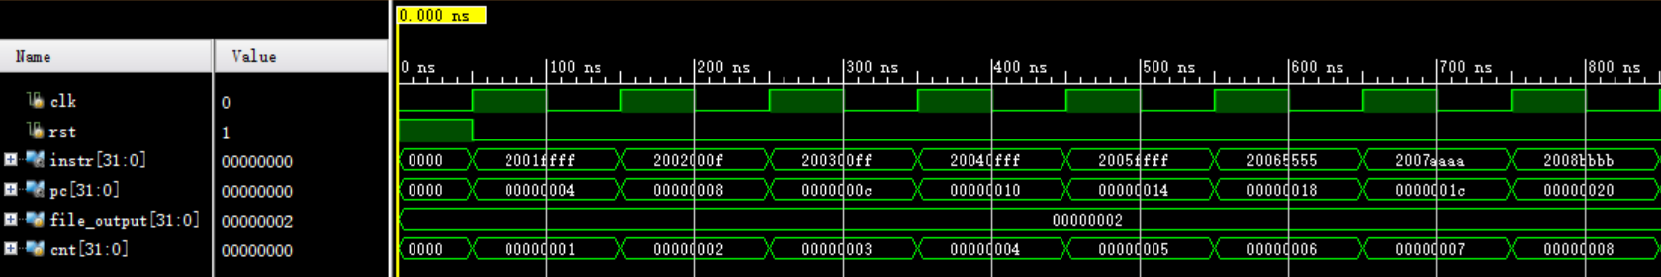

42.45 Mfc0 Mtc0

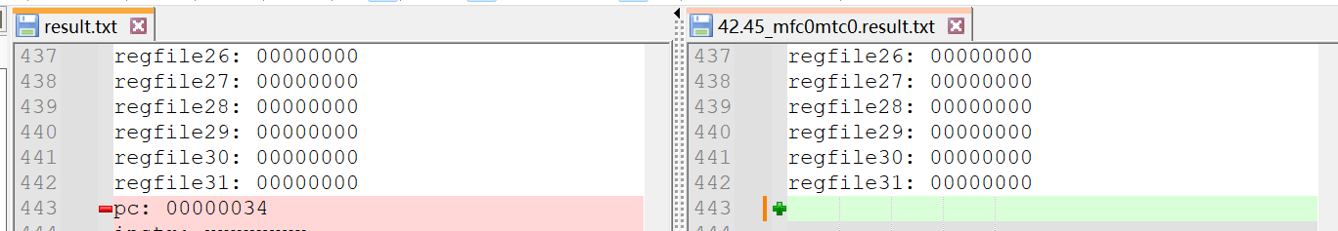

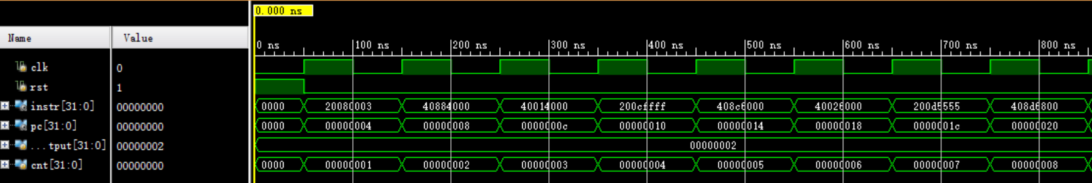

43.46 Mfhi Mthi

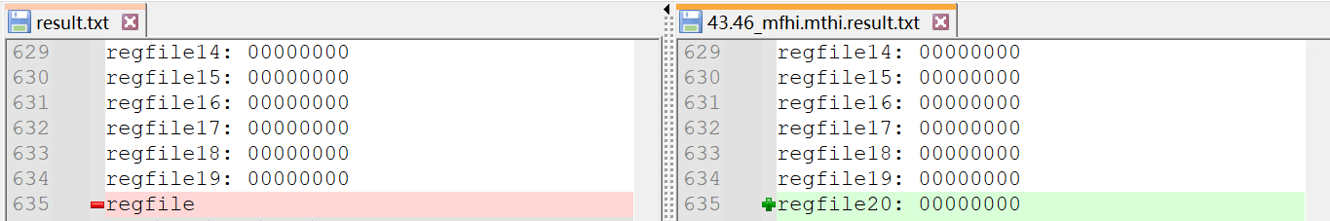

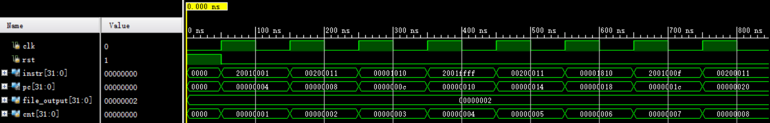

44.47 Mflo Mtlo

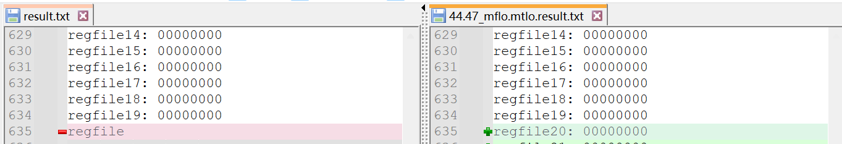

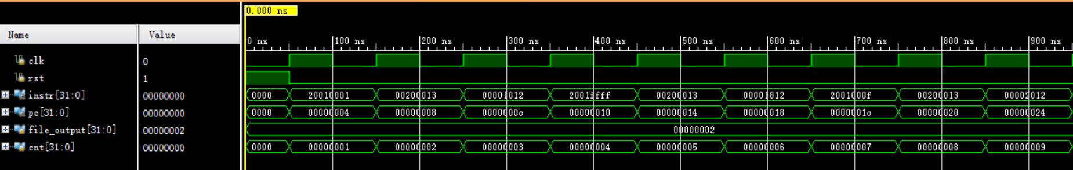

1. Mult

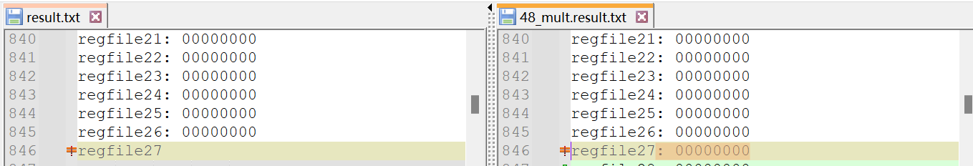

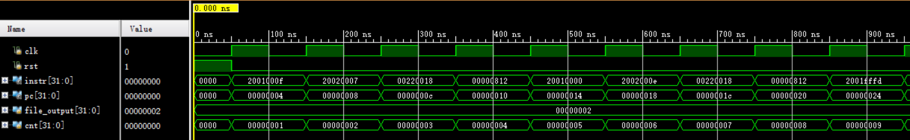

1. Multu

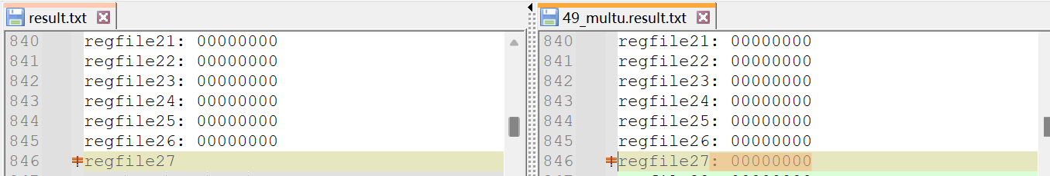

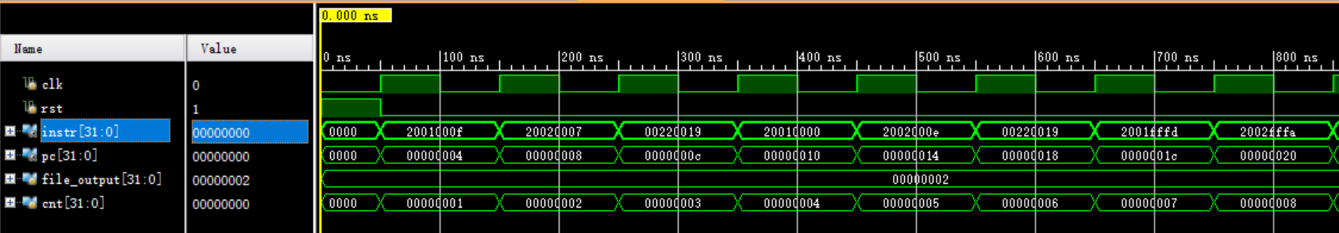

1. Bgez

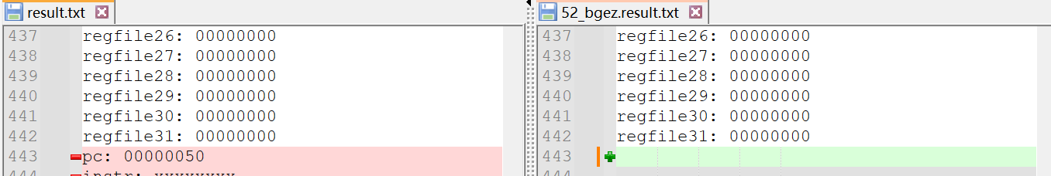

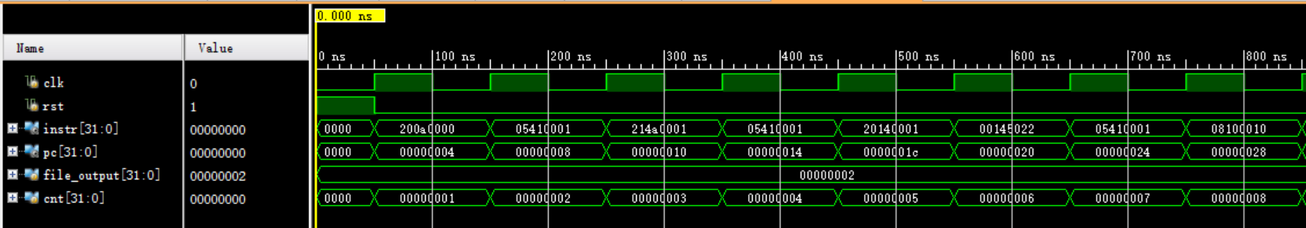

1. Div

